Multiple-choice section – choose the correct answer

Question 1 [6.1]

φ and θ are the two non-right angles in a triangle. If sin(φ) = and tan(θ) = , then tan(θ) × sin(φ) is:

A  B  C  D 

Question 2 [6.1]

If sin(θ) = 0.8 then sin(2θ) is:

**A** 0.82 **B** 0.96 **C** 0.63 **D** 0.47

Question 3 [6.2]

The value of x is:

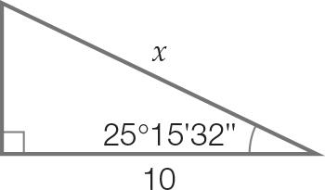

A 13.04 B 12.95 C 10.32 D 11.06

Question 4 [6.2]

The string of a kite makes an angle of 54° 10' with the horizontal. If the length of string is 32 m, the height of the kite in metres is:

A 18.7 B 44.3 C 25.9 D 20.6

Question 5 [6.3]

The shadow of a 5 m tree at 1 p.m. was 6 m long. If the shadow increases in length by 50 cm/hour, what angle will the end of the shadow make with the treetop at 4 p.m.?

A 43° 24' B 50° 18' C 39° 42' D 33°42'

Question 6 [6.3]

A rectangular gate 4 m long and 3 m wide is strengthened by a diagonal support. The smaller of the angles the diagonal makes with the sides of the gate is closest to:

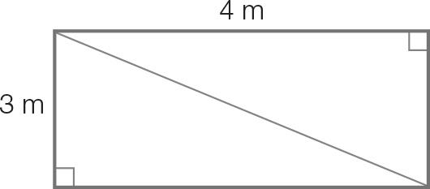

A 53° B 44° C 61° D 37°

Question 7 [6.4] 6.4]

An aircraft takes off at an angle of elevation of 72°21' from the runway. What distance has the aircraft travelled through the air when its altitude is 10 500 m, correct to the nearest metre?

A 11 019 m B 34 630 m C 3184 m D 10 005 m

Question 8 [6.5] 6.5

The angle θ is measured clockwise from north. If sin(θ) = 0.383, then the direction θ as a compass bearing is:

A 22°30'T B N67°30'W C N22°30'E D 112°30'T

Question 9 [6.5] 6.5

Adam walked 2 km in a direction S45°W and then walked due north until his bearing from the start was 315° T. He then walked back to the starting point. The total distance Adam walked, correct to 1 decimal place is:

A 2.8 km B 6.8 km C 4.1 km D 3.4 km

Question 10 [6.6] 6.6

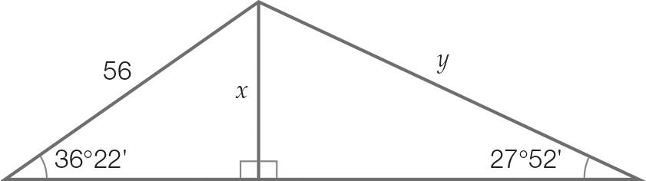

The value of y, correct to 2 decimal places is:

A 33.21 B 66.42 C 71.05 D 50

Multiple-choice total marks: __ / 10

Short answer section

Question 11 2 marks [6.2]

A seesaw is 2.4 m long. At its highest point off the ground it makes an angle of 48° with the ground. Write both answers correct to 2 decimal places.

(a) What is the maximum height above the ground of the end of the seesaw?

(b) What is the height above the ground of the centre support of the seesaw?

Question 12 4 marks [6.3]

A set of stairs has a vertical height of 2.2 m and it covers a horizontal distance of 1.5 m.

(a) What angle does the stairs make with the ground in degrees, minutes and seconds?

(b) If there are 8 steps, not including the ground level or the top level, how far apart (in cm) are the steps?

Question 13 7 marks [6.2, 6.3, 6.5]

A block of land ABCD is in the shape of a parallelogram, where AD is parallel to BC. The angle at A is 80.41° and the angle at D is a right angle. BC is 70 m and AD is 74 m.

(a) Show that the total length of fencing required is 192 m, correct to the nearest metre.

(b) A pipe is to be laid along the diagonal BD. What is the length of D from B?

(c) The pipe will cost $25 per metre to lay. What will be the total cost?

(d) What is the bearing, using degrees, minutes and seconds, of point D from point B?

Question 14 7 marks [6.2, 6.3, 6.5]

An observation post is situated on a bearing of 50°T at a distance of 48 km from a crossroad. A second observation post is located 28 km due east of the first post.

(a) How far east and how far north, correct to 2 decimal places of the crossroad is the first observation post?

(b) What is the distance, correct to the nearest kilometre, of the second observation post from the crossroad?

(c) What is the true bearing, using degrees, minutes and seconds, of the second observation post from the crossroad?

Question 15 2 marks [6.6]

A right pyramid stands on a square base of side length 10 cm. The perpendicular height of the pyramid is 21 cm. Calculate the angle a sloping face makes with the base, to the nearest second.

Short answer total marks: __ / 22

Extended answer section

Question 16 4 marks [6.2, 6.3]

A pendulum of length 25 cm forms an isosceles triangle ABC as it swings from A to C.

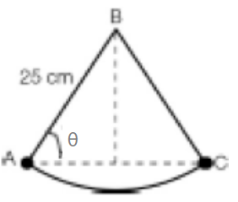

(a) If the length of AC is 20 cm, calculate θ in degrees, minutes and seconds.

(b) The length of the pendulum is doubled and the angle of swing remains the same. What is the length AC?

Question 17 5 marks [6.5]

Alana hiked 10 km in the direction N70°E. Bree set out from the same point and hiked 24 km in the direction 340°T.

(a) What is the distance between the two at the end of the hikes?

(b) What is the true bearing of Alana from Bree, correct to the nearest degree?

(c) How far east of Alana is Bree, correct to the nearest km?

Question 18 7 marks [ 6.6]

A radio mast is supported by two wires for safety, as shown the diagram below. Safety regulations require that the angle θ must not exceed 77°.

(a) Calculate the value of θ and state whether the mast is safe.

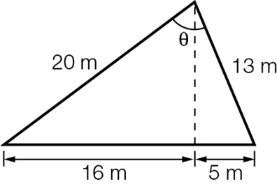

(b) What is the height of the mast?

(c) The 13 m wire is to be increased length. Calculate how much longer this wire could be extended so that the mast is still safe. Give your answer correct to the nearest centimetre.

Extended answer total marks: __ / 16

TOTAL test marks: __ / 48